**LISTING**

**ALGORITMA DAN PEMROGRAMAN**

**Pertemuan ke-3**

**PRAKTIK 1**

**1. 1st program to count total that must be paid by first person**

public class Tip01{

public static void main(String[]args){

double person1=10;

double total1=person1*(1+0.5+0.15);

System.out.println("Person 1:$"+total1);

}

}

Output:

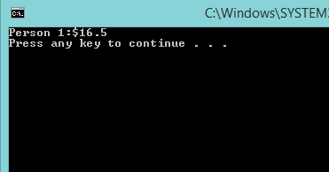

**2. 2nd program to count total that must be paid by each person**

public class Tip02{

public static void main(String[]args){

double person1=10;

double total1=person1*(1+0.05+0.15);

System.out.println("Person 1:$"+total1);

double person2=12;

double total2=person2+(person2*(0.05+0.15));

System.out.println("Person 2:$"+total2);

double person3=9;

double total3=person3+(person3*(0.05+0.15));

System.out.println("Person 3:$"+total3);

double person4=8;

double total4=person4*(1+0.05+0.15);

System.out.println("Person 4:$"+total4);

double person5=7;

double total5=person5*(1+0.05+0.15);

System.out.println("Person 5:$"+total5);

double person6=15;

double total6=person6*(1+0.05+0.15);

System.out.println("Person 6:$"+total6);

double person7=11;

double total7=person7*(1+0.05+0.15);

System.out.println("Person 7:$"+total7);

double person8=30;

double total8=person8*(1+0.05+0.15);

System.out.println("Person 8:$"+total8);

}

}

Output:

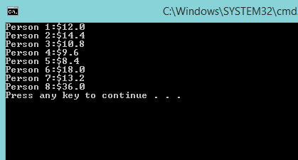

**3. Using tax and tip variable**

public class Tip03{

public static void main(String[]args){

double tax=0.05;

double tip=0.15;

double person1=10;

double total1=person1+(person1*(tax+tip));

System.out.println("Person 1:$"+total1);

double person2=12;

double total2=person2+(person2*(tax+tip));

System.out.println("Person 2:$"+total2);

double person3=9;

double total3=person3+(person3*(tax+tip));

System.out.println("Person 3:$"+total3);

double person4=8;

double total4=person4*(1+tax+tip);

System.out.println("Person 4:$"+total4);

double person5=7;

double total5=person5*(1+tax+tip);

System.out.println("Person 5:$"+total5);

double person6=15;

double total6=person6*(1+tax+tip);

System.out.println("Person 6:$"+total6);

double person7=11;

double total7=person7*(1+tax+tip);

System.out.println("Person 7:$"+total7);

double person8=30;

double total8=person8*(1+tax+tip);

System.out.println("Person 8:$"+total8);

}

}

Output:

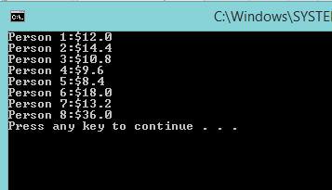

**4. Using method**

public class Calculator{

//field

public double tax=0.05;

public double tip=0.15;

//methods

public double findTotal(double originalPrice){

double total=originalPrice+ (originalPrice*(tax+tip));

return total;

}

public static void main(String[]args){

Calculator calc = new Calculator();

System.out.println("Tax:"+calc.tax);

System.out.println("Tip:"+calc.tip);

System.out.println("Person 1:$"+calc.findTotal(10));

System.out.println("Person 2:$"+calc.findTotal(12));

System.out.println("Person 3:$"+calc.findTotal(9));

System.out.println("Person 4:$"+calc.findTotal(8));

System.out.println("Person 5:$"+calc.findTotal(7));

System.out.println("Person 6:$"+calc.findTotal(15));

System.out.println("Person 7:$"+calc.findTotal(11));

System.out.println("Person 8:$"+calc.findTotal(30));

}

}

Output:

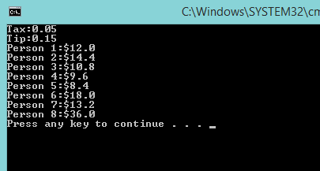

**5. Method with a parameter : change tip to 10%**

public class Calculator1{

//field

public double tax=0.05;

public double tip=0.15;

//methods

public double findTotal(double originalPrice){

double total=originalPrice+(originalPrice*(tax+tip));

return total;

}

public static void main(String[]args){

Calculator calc = new Calculator();

calc.tip=0.10;

System.out.println("Tax:"+calc.tax);

System.out.println("Tip:"+calc.tip);

System.out.println("Person 1:$"+calc.findTotal(10));

System.out.println("Person 2:$"+calc.findTotal(12));

System.out.println("Person 3:$"+calc.findTotal(9));

System.out.println("Person 4:$"+calc.findTotal(8));

System.out.println("Person 5:$"+calc.findTotal(7));

System.out.println("Person 6:$"+calc.findTotal(15));

System.out.println("Person 7:$"+calc.findTotal(11));

System.out.println("Person 8:$"+calc.findTotal(30));

}

}

Output:

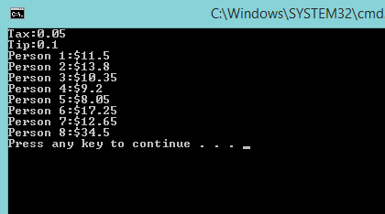

**6. Method without parameter : get a tip value**

public class Calculator2{

//field

public double tax=0.05;

public double tip=0.15;

//methods

public double getTip(){

return tip;

}

public double findTotal(double originalPrice){

double total=originalPrice*(1+tax+tip);

return total;

}

public static void main(String[]args){

Calculator2 calc=new Calculator2();

calc.tip=0.10;

System.out.println("Jumlah Tip(%):"+(calc.getTip()*100));

}

}

Output:

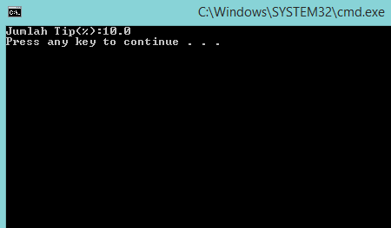

**7. Method without return value : print tip**

public class Calculator3{

//field

public double tax=0.05;

public double tip=0.15;

//methods

public double getTip(){

return tip;

}

public void printTip(){

System.out.println("Jumlah Tip:"+tip);

}

public double findTotal(double originalPrice){

double total=originalPrice*(1+tax+tip);

return total;

}

public static void main(String[]args){

Calculator3 calc=new Calculator3();

calc.printTip();

}

}

Output:

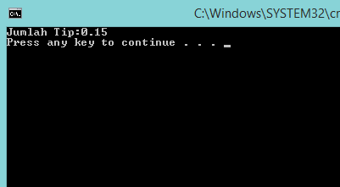

**8. Method with return value : getTip method**

public class Calculator4{

//field

public double tax=0.05;

public double tip=0.15;

//methods

public double getTip(){

return tip;

}

public void printTip(){

System.out.println("Jumlah Tip:"+tip);

}

public double findTotal(double originalPrice){

double total=originalPrice*(1+tax+tip);

return total;

}

public static void main(String[]args){

Calculator4 calc=new Calculator4();

double tip=calc.getTip();

System.out.println("Jumlah Tip:"+tip);

}

}

Ouput:

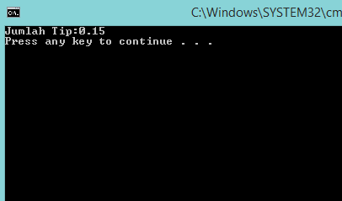

**PRAKTIK 2**

**1. Using/import scanner class package**

public class Calculator5{

//field

public double tax=0.05;

public double tip=0.15;

//methods

public double findTotal(double originalPrice){

double total=originalPrice*(1+tax+tip);

return total;

}

public static void main(String[]args){

java.util.Scanner keyboard=new java.util.Scanner(System.in);

Calculator5 calc=new Calculator5();

calc.tip=0.10;

System.out.println("Tax:"+calc.tax);

System.out.println("Tip:"+calc.tip);

System.out.println("Enter the originalPrice:");

Double originalPrice=keyboard.nextDouble();

System.out.println("Person :$"+calc.findTotal(originalPrice));

}

}

Output:

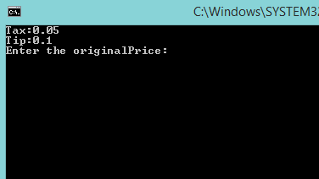

**2. Import package, can be write below**

import java.util.Scanner;

public class TestCalculator{

public static void main(String[]args){

Scanner keyboard=new Scanner(System.in);

Calculator calc=new Calculator();

System.out.println("Enter the originalPrice:");

Double originalPrice=keyboard.nextDouble();

System.out.println("Person:$"+calc.findTotal(originalPrice));

}

}

Output:

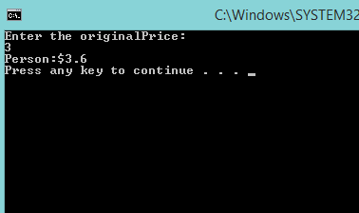

**LATIHAN**

**1. Make program to show nim, name, major, ipk from keyboard input**

import java.util.Scanner;

public class Nanang{

public static void main(String[]args){

int NIM;

String Nama, Jurusan;

double IPK;

Scanner keyboard=new Scanner(System.in);

System.out.println("Masukkan Nama");

Nama= keyboard.next();

System.out.println("Masukkan NIM");

NIM= keyboard.nextInt();

System.out.println("Masukkan Jurusan");

Jurusan= keyboard.next();

System.out.println("Masukkan IPK");

IPK= keyboard.nextDouble();

System.out.println("===========================");

System.out.println(" Nama:"+Nama );

System.out.println(" NIM:"+NIM );

System.out.println(" Jurusan:"+Jurusan );

System.out.println(" IPK:"+IPK );

System.out.println("===========================");

}

}

Output:

